-

Project Report
on

Title of the project

Submitted by

Project Members

Student Name with PRN Number

Under the Guidance of

Prof. /Dr

Under the External Guidance of (if applicable)

Department of Computer Engineering and Technology,
School of Computer Science and Engineering,
MIT World Peace University, Kothrud,
Pune 411 038, Maharashtra - India
2025-2026


DEPARTMENT OF COMPUTER ENGINEERING AND TECHNOLOGY

C E R T I F I C A T E

This is to certify that, Student Names

of BTech. CSE (Cybersecurity and Forensics) have completed their project titled “Mention Project title here” and have submitted this Capstone Project Report towards fulfillment of the requirement for the Degree-Bachelor of Computer Science & Engineering (BTech-CSF) for the academic year 2025-2026.

[Dr/ Prof. ] | [Dr. Vinayak Musale] | [Dr. Balaji M Patil]
Project Guide  Department of CET  MIT World Peace University, Pune | Program Coordinator  BTech. CSE (Cybersecurity and Forensics)  Department of CET  MIT World Peace University, Pune | Program Director  Department of CET  MIT World Peace University, Pune

Internal Examiner:

External Examiner:

Date:
Acknowledgement

Name of the Students

Abstract

List of Figures

1.1 | Overview…………………………………………….. | 3
1.2 | Block Diagram……………………………………….. | 4

List of Tables

1.1 | Information ………………………………………… | 3
2.1 | Literature Survey…………………………………… | 10

Contents

Abstract . . . . . . . . . . . . . . . . . . . . . . . . . . . . . . . . . . . . . . . . . . . . . . . . …….……. ..I
List of Figures . . . . . . . . . . . . . . . . . . . . . . . . . . . . . . . . . . . . . . . . . . . . ….…… …II
List of Tables . . . . . . . . . . . . . . . . . . . . . . . . . . . . . . . . . . . . . . . . . ….. . ….…... . III

1 | Introduction |  |  | 1
 | 1.2 |  |  | 2
 |  | 1.2.1
2 | Literature Survey
 | 2.1
 |  | 2.1.2
3
4
 | References
 | Conclusion
 | Future prospects of the project
 | References
 | Publication Details
 | Appendices
 | A. Base Paper(s)
 | B. Plagiarism Report from any open source

Chapter 1

Introduction

Content goes here. None of the chapter to start with any heading. Add a paragraph. Introduce your project properly

  - Subheading1
1.2.1 Subheading 2

 | Formal Language | Natural Language

Table1.1: Difference between Natural and Formal Language [11]

Chapter 2

Literature Survey

Content goes here

  - Subheading1
    - Subheading 2
    - S
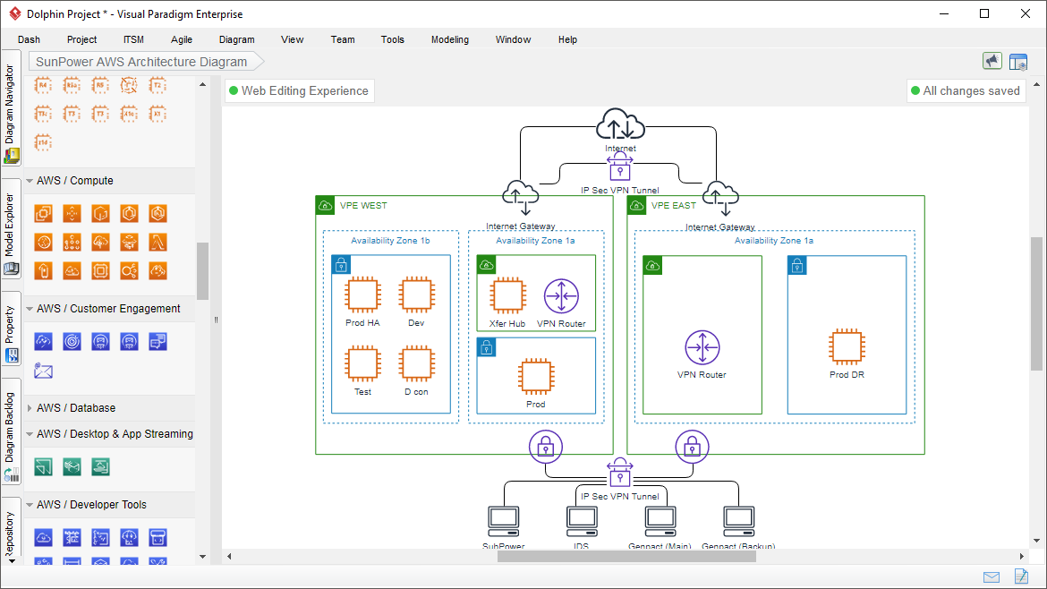
Figure 2.1: AWS Architecture

References

[1] Manisha Chandak, Sheetal Girase, Introducing hybrid technique for optimization of book recommender system, International Conference on Advanced Computing Technologies and Applications (ICACTA-2015), Procedia Computer Science page nos- 23 – 31, ELSEVIER
[2]

